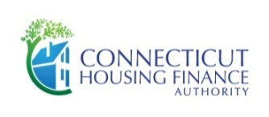
Connecticut Housing Finance Authority

REVERSAL OF CURTAILMENT OR LEVEL PAYMENT

PERIOD ENDED: _______ / _______ / _______

IF MULTIPLE LEVEL PAYMENTS ARE TO BE REVERSED, USE A SEPARATE LINE FOR EACH PAYMENT.
IDENTIFY WITH "C" FOR REVERSAL OF CURTAILMENT OR "N" FOR REVERSALOF LEVEL PAYMENT.

MORTGAGOR’S LAST NAME | SIX DIGIT CHFA LOAN # | AMOUNT OF REVERSAL | ORIGINAL DATE REPORTED | C or N
 | TOTAL (RC/RN):

IRRG\EXCEPT-RC/RN FORM.DOCX

